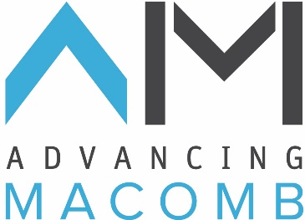
January 6, 2017
---- PRESS RELEASE ----
Advancing Macomb Supports Mt. Clemens Riverfront Development

Advancing Macomb is proud to announce its fourth project – $10,000 to support crowdfunding for the downtown WaterTowns® Mt. Clemens riverfront project.

“In Macomb County, the Clinton River is our ‘Main Stream Main Street,” said County Executive Mark Hackel. “It’s also the gateway to Lake St. Clair’s boating paradise.”

Thanks to the Clinton River Watershed Council, there will be access for paddling sports right in downtown Mt. Clemens with a new universally accessible kayak launch at MacArthur Park.
Conveniently located next to the YMCA and is within walking and biking distance to many great downtown restaurants and attractions. Amenities and enhancements along the Water Trail will provide opportunities for paddlers to stop and experience destinations along the trail that otherwise would be missed.
“Anne Vaara and her team at the Clinton River Watershed Council have unearthed exciting possibilities for the river. Advancing Macomb supports positive and transformative community, economic and natural resource projects. This paddling launch in downtown Mt. Clemens encompasses all of our principles. We are proud to support this project and grateful for AT&T joining us for this contribution,” said Advancing Macomb Chair, Dave Girodat.

“At AT&T, we are always looking for opportunities to promote and enhance our local communities, and this riverfront development presents a great opportunity to make that kind of positive impact,” said Jim Murray, president of AT&T Michigan. “Making efforts to more fully utilize Macomb’s waterways will undoubtedly attract and promote new and increased activity throughout the community and that’s great news for everyone.”
The crowdfunding campaign is happening now to add new adventures and enhancing summer time fun for all of us in Macomb. With its close proximity to Lake St. Clair, MacArthur Park in Downtown Mt. Clemens is a perfect location for the first inclusive universally accessible canoe/kayak launch.
“Our goal is to raise $60,000 in 60 days,” Vaara said. Donations of any amount are accepted and appreciated. However, if fundraising goals are met for the new kayak and canoe launch, the Michigan Economic Development Corporation and the Michigan State Housing Development Authority’s Public Spaces Community Places program will match funds up to $50,000.
Online donations can be made at patronicity.com/project/macarthur_park_river_access before Jan. 28, 2017, and by contacting the CRWC at (248) 601-0606.

Advancing Macomb Projects To-date:
September 2014 – Freedom Hill Playground Enhancement
February 2015 & Ongoing – Manufacturing Marketing and Business Development
September 2016 – May 2017 – Eastside Bike Drive
December 2016 – Clinton River Watershed Council Mt. Clemens Riverfront Project

Advancing Macomb Advancing Macomb is a business and community leadership group led by over 20 leading employers, three principal business organizations and the largest higher educational institution in Macomb County, an area encompassing approximately 900,000 residents and 18,000 businesses. Our organization is committed to enhancing local communities by leveraging a unified civic leadership voice throughout the Detroit region. www.advancingmacomb.com

